8 Queen Problem

Aim
To develop a Python program to solve the 8-Puzzle problem

Algorithm
- Define the initial state of the 8-puzzle.
- Define the goal state.
- Calculate the Manhattan Distance heuristic for each state.
- Find the position of the blank tile (0).
- Generate all possible neighboring states by moving the blank tile.
- Apply the A* Search Algorithm to explore the state with the minimum cost.
- Continue until the goal state is reached.
- Display the sequence of moves from the initial state to the goal state.

Pseudo Code
START

Input the initial state of the puzzle.
Define the goal state.

Create a priority queue.
Insert the initial state into the queue.

WHILE priority queue is not empty DO
Remove the state with the lowest cost.

IF current state is the goal state THEN
Display the solution path.
STOP.
END IF

Mark the current state as visited.

Generate all valid neighboring states.

FOR each neighboring state DO
IF it is not visited THEN
Calculate:
f(n) = g(n) + h(n)
Insert it into the priority queue.
END IF
END FOR
END WHILE

Display "No solution exists."

STOP
Code -
from heapq import heappush, heappop
GOAL = ((1, 2, 3),
(4, 5, 6),
(7, 8, 0))
# Manhattan Distance Heuristic
def heuristic(state):
distance = 0
for i in range(3):
for j in range(3):
value = state[i][j]
if value != 0:
goal_x = (value - 1) // 3
goal_y = (value - 1) % 3
distance += abs(i - goal_x) + abs(j - goal_y)
return distance
# Find position of blank tile (0)
def find_blank(state):
for i in range(3):
for j in range(3):
if state[i][j] == 0:
return i, j
# Generate neighboring states
def get_neighbors(state):
neighbors = []
x, y = find_blank(state)
directions = [(-1, 0), (1, 0), (0, -1), (0, 1)]
for dx, dy in directions:
nx, ny = x + dx, y + dy
if 0 <= nx < 3 and 0 <= ny < 3:
new_state = [list(row) for row in state]
new_state[x][y], new_state[nx][ny] = new_state[nx][ny], new_state[x][y]
neighbors.append(tuple(tuple(row) for row in new_state))
return neighbors
# A* Search Algorithm
def solve(start):
pq = []
heappush(pq, (heuristic(start), 0, start, []))
visited = set()
while pq:
f, g, current, path = heappop(pq)
if current in visited:
continue
visited.add(current)
path = path + [current]
if current == GOAL:
return path
for neighbor in get_neighbors(current):
if neighbor not in visited:
heappush(pq, (g + 1 + heuristic(neighbor), g + 1, neighbor, path))
return None
# Print puzzle
def print_board(state):
for row in state:
print(" ".join(str(x) if x != 0 else "_" for x in row))
print()
# Driver Code
start = ((1, 2, 3),
(4, 0, 6),
(7, 5, 8))
solution = solve(start)
if solution:
print("Solution found in", len(solution) - 1, "moves:\n")
for step in solution:
print_board(step)
else:
print("No solution exists.")

Input

1 2 3

4 0 6

7 5 8

Output

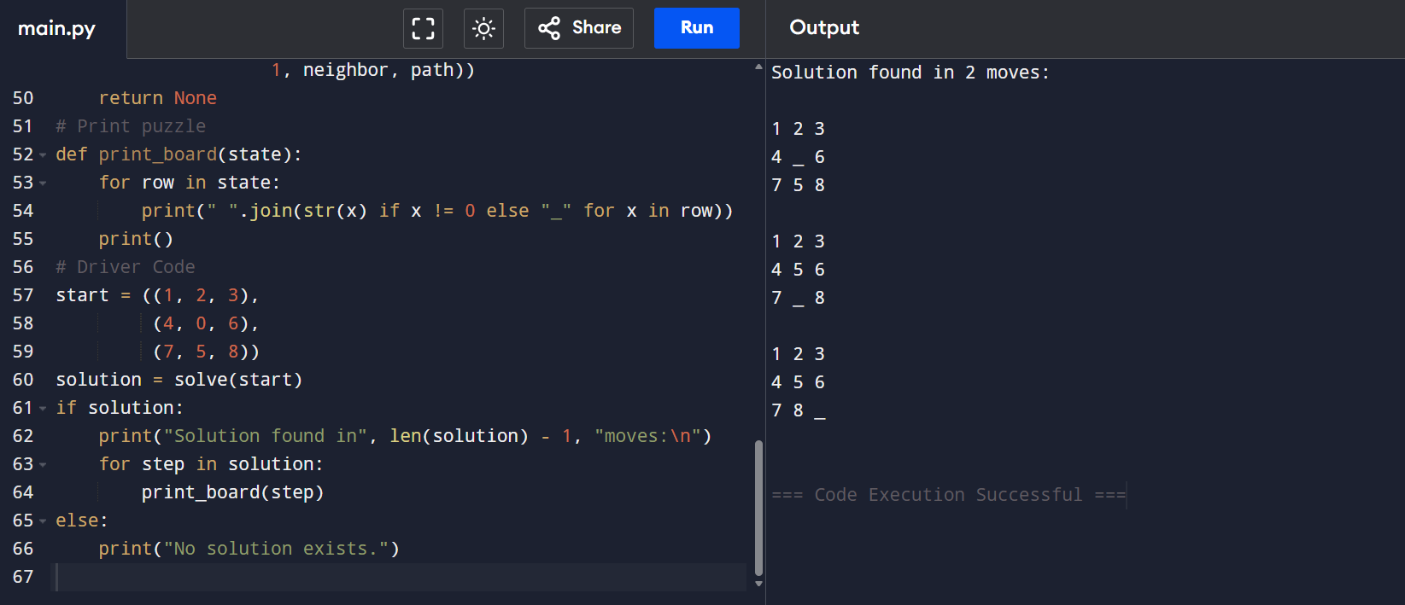

Result –

Hence, The 8 puzzle problem is solved using Python Program.

